Semi-Report

Charlie Nitschelm  
11/4/19  
Modern Physics

# Problem 9 – Experimental Methods

In this section, there will be two experiments that will be explained for the purpose of the reader to understand what was done, and the ability to do the experiment again.

## Measuring the Wavelength of a He-Ne Laser

A double-slit plate was utilized to produce a phenomenon known as the double-slit experiment. A helium-neon laser was used to aim at various sizes of double slits, with the slit plate placed exactly 1 meter away from a cardboard screen. The overall setup should look like the figure below.

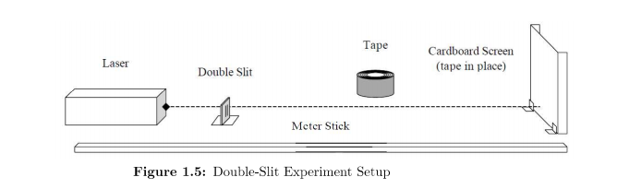

Figure 1- The double slit experimental setup

The spacing produced on the cardboard screen were then measured for distance between maxima and were recorded for each for the fringe spacing measurement. The slit width changed between each measurement, producing a different overall result being per slit tested. It was also important to record the slit spacing and the device uncertainty of the caliper being used to factor that result into the overall conclusions made from the report. The bright spots on the screen were produced due to light wave interference, with the peaks of each of the waves going through the slit constructively interfering and colliding at the bright spot, and the waves deconstructivity interfering at the dark spots. The overall effect of changing the slit width was that the average fringe spacing would increase proportional to the change in width until the lights size is no longer big enough to hit both slits.

## Measuring Data on a CD

A laser beam and a reflecting screen was used to take in a CD and measure the total amount of data that can be stored onto the disk. The viewing screen is placed directly perpendicular to the disk, while the laser was positioned a known theta away and pointed at the CD such that it would reflect and hit the viewing screen. The overall experimental setup can be seen in the figure below.

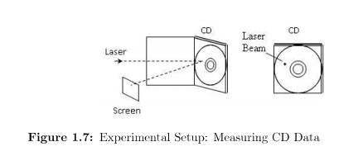

Figure 2 - The CD spacing experimental setup

You will find that you can make more than one measurement for the angular position $ϴ_{1}$. You then change the total angle theta multiple times and obtain multiple data points for each and follow the rules for averaging them to obtain a reliable data point for the maxima of that angle. The main distance measurement obtained would be the bright peak distance and the track spacing of the light spots.

# Problem 10 – Results

## Results of Measuring the Wavelength of a He-Ne Laser

Using the measurements from the experiment, we were able to get an average value of fringe spacing, and using the wavelength equation, get values of the light’s wavelength with its accompanying uncertainty. This allowed us to analyze the main sources of uncertainty in the experiment and obtain a way to measure lights wavelength. The thought question of using an electron gun was proposed as well, letting us research on how even electrons will behave the same way as they interfere with themselves as they travel through each slit.

## Results of Measuring Data on a CD

X, the screen distance and $Y_{m}$, the overall distance, were measured directly from the physical setup. The wavelength of light was also known that was shined onto the CD. That data could be used to calculate the $ϴ_{m}$ and its respective uncertainty. The track spacing $h_{m}$ could also be calculated the same way leading to an overall track spacing on the CD of h. That data, using fundamental data storage equations, could be used to calculate the theoretical total amount of data storage that can be put onto a CD. The general trend was with denser spacing, the more data can be stored on the CD. That is why DVD’s, with smaller spacing, has a larger data density storage. With a larger m order, though, the $Y_{m}$ that was measured yielded slightly higher values in general, yielding even larger overall track spacing and angular position. The end result was a total of 400000000 bits.